2024

POWER BI DASHBOARD

MARKETING MANAGEMENT

**wadia yousaf Sec H 21U00605**

**Table of Contents**

Summary 2

Key Findings 2

Appendix 3

# Summary

This dashboard provides valuable insights into consumer buying patterns, focusing on sales, transactions, and customer behavior. The key metrics include a total sales amount of $233K, compared to previous sales of $99K. The average purchase amount stands at $59.76, with a total of 3,900 transactions recorded. Discounts have been applied to 43% of transactions, and 27% of customers are subscribed. PayPal is the most popular payment method, and the average review rating is 3.75 out of 5. The dashboard also includes additional filters for location, customer age group, and seasonal preference (Fall, Spring, Summer, Winter). A gauge chart visually compares the total sales of $233K against the target sales goal of $466K. (Refer to Exhibit A)

The consumer behavior analysis dashboard offers insights into sales, customer demographics, and purchasing patterns. Key findings include the popularity of clothing and accessories among customers, a higher proportion of male customers, a preference for medium-sized clothing, a significant number of discounted transactions, and seasonal sales trends. Additionally, the dashboard highlights the top-performing locations and the most active customer age group. This information is valuable for businesses to make informed decisions about marketing strategies and product offerings. Dashboard contains filters related to customer age and location so it will be easy to update the data. (Refer to Exhibit B)

# Key Findings

* **Sales by Category:** Clothing is the top-selling category, followed by accessories and footwear.
* **Sales by Gender:** Male customers account for 68% of sales, while female customers represent 32%.
* **Sales by Size:** Medium (M) is the most popular size, followed by large (L) and small (S).
* **Discounted Transactions:** 43% of transactions involve discounts.
* **Sales by Season:** Fall and spring are the top-selling seasons.
* **Top 3 Locations by Sale:** West Virginia, Wyoming, and Wisconsin are the top-performing locations.

# Appendix

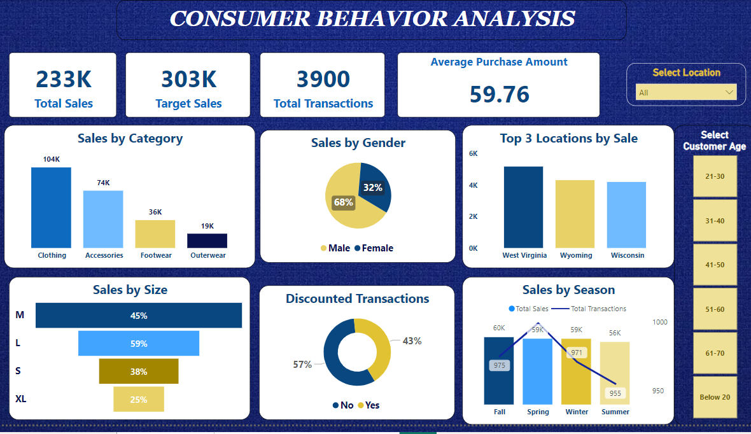**Exhibit A**

**Exhibit B**